

Josh’s Project

Event subtitle

07/10/2020 |

Queenstown

Contents

1. Login 3

1. Calendar 4

2. Select Service 4

3. Select date and time 5

4. Customer information 6

5. Confirm appointment 7

7. Select service and provider 8

8. Calendar 9

9. Select appointment and edit 9

10. Edit appointment 10

11. Add customer 10

12. Check customer details 11

13. Add services 11

14. Check Service 12

15. Add providers 12

16. Check providers details 13

17. Settings General 13

18. Settings business logic 14

19. Settings legal contracts 14

20. Settings Current User 15

21. Settings About Easy Appointments 15

## Login

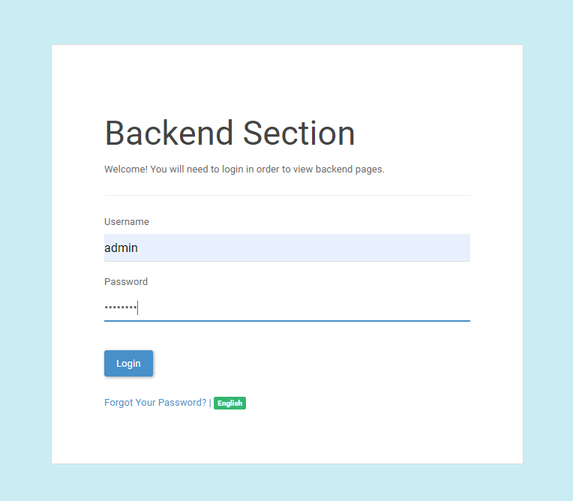

1. Calendar  
   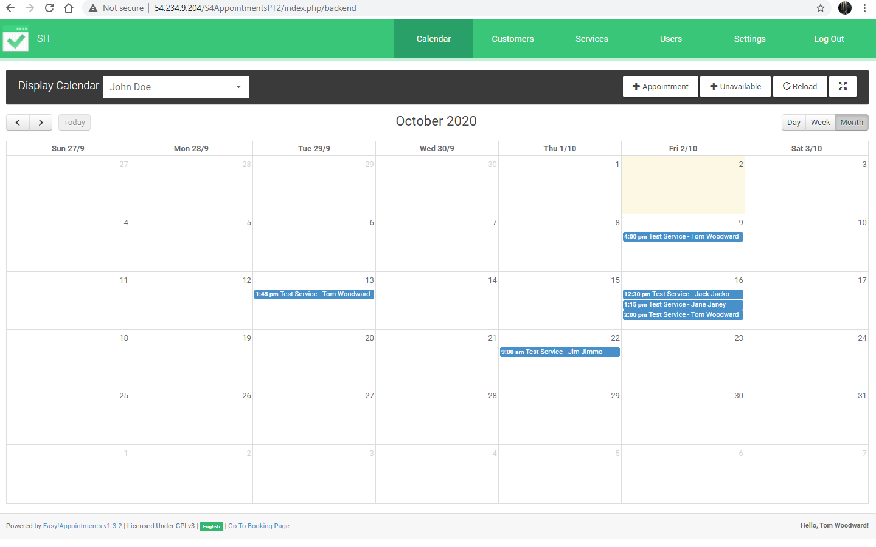
2. Select Service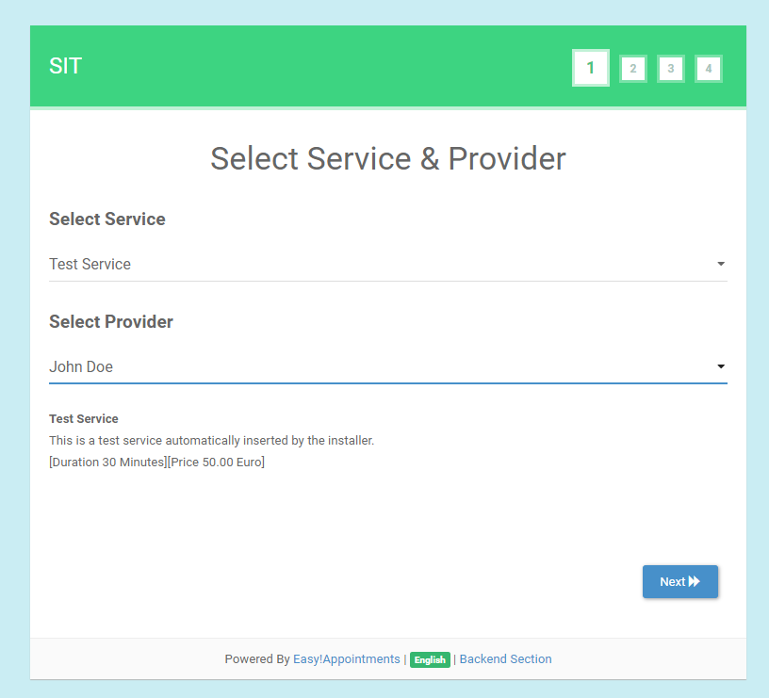
3. Select date and time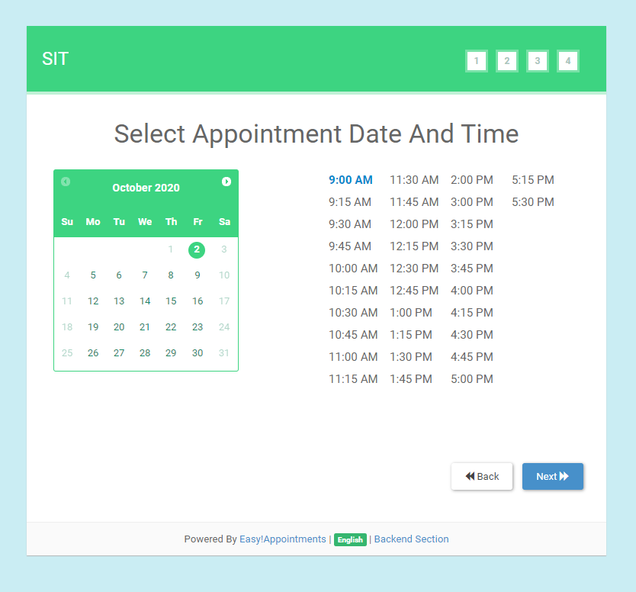
4. Customer information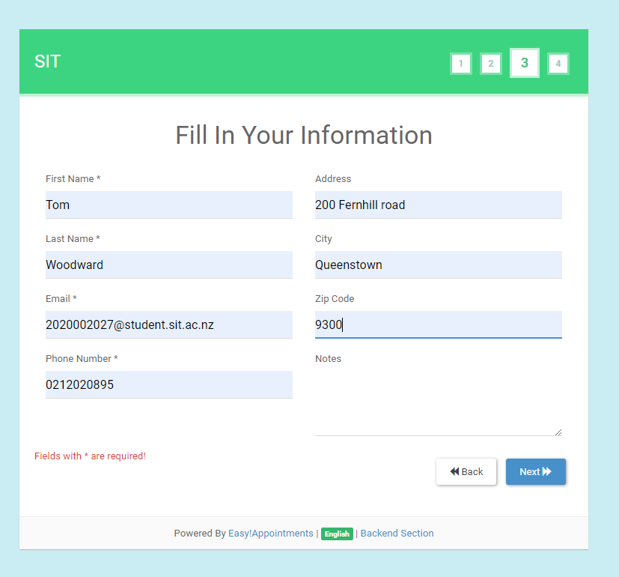
5. Confirm appointment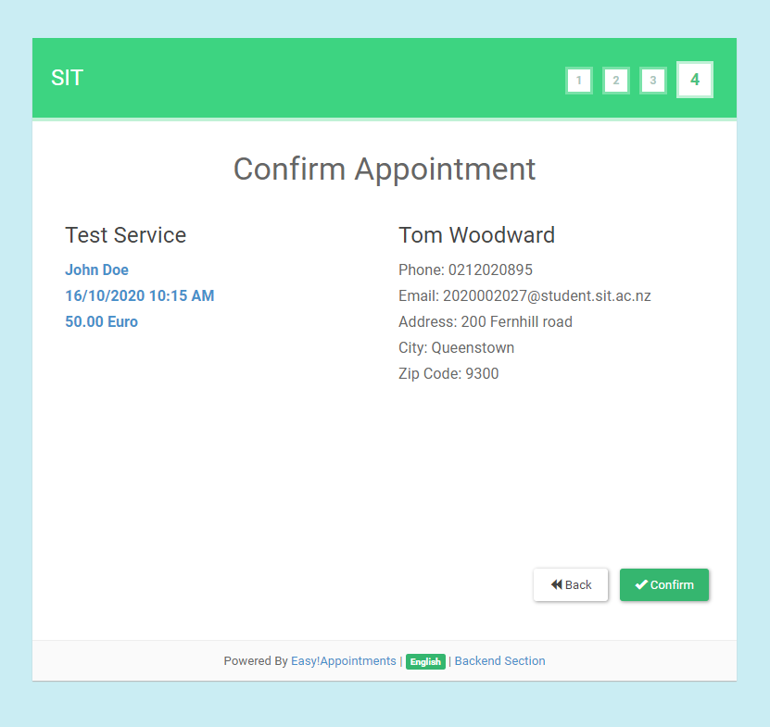
6. Appointment registration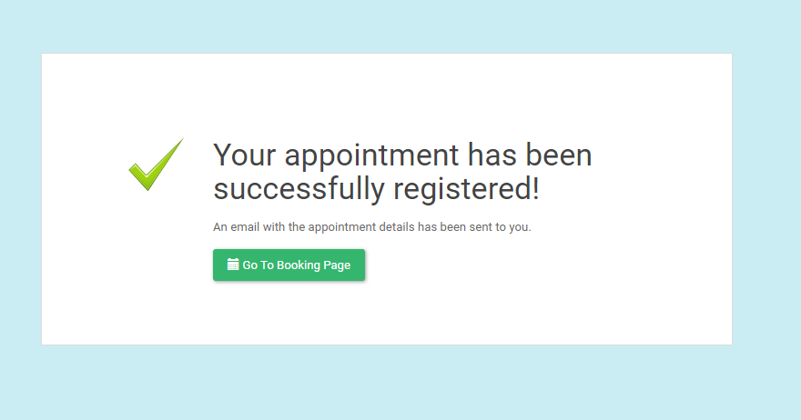
7. Select service and provider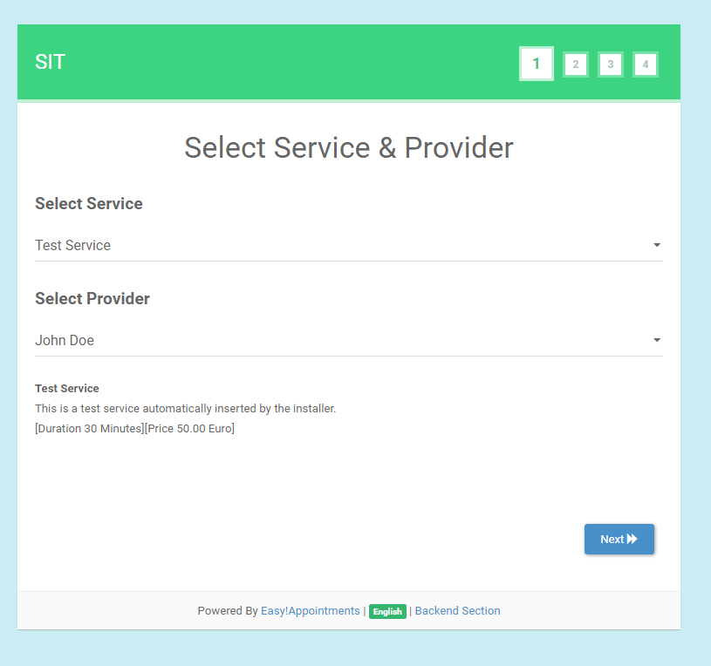
8. Calendar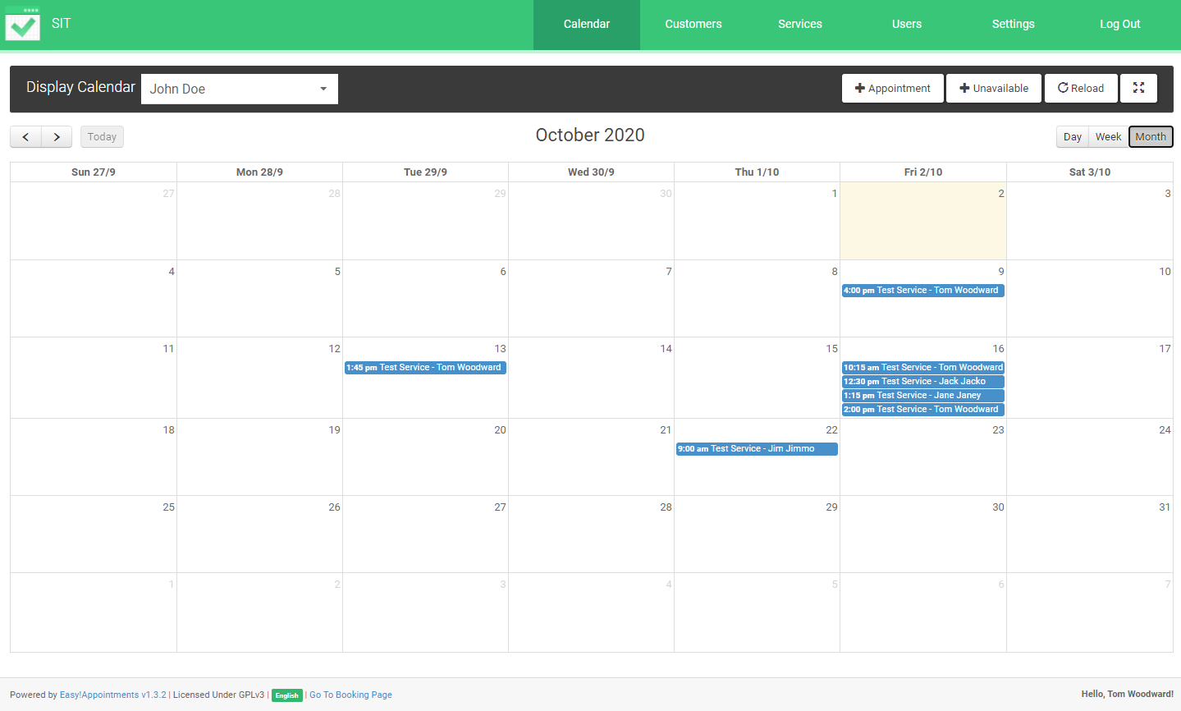
9. Select appointment and edit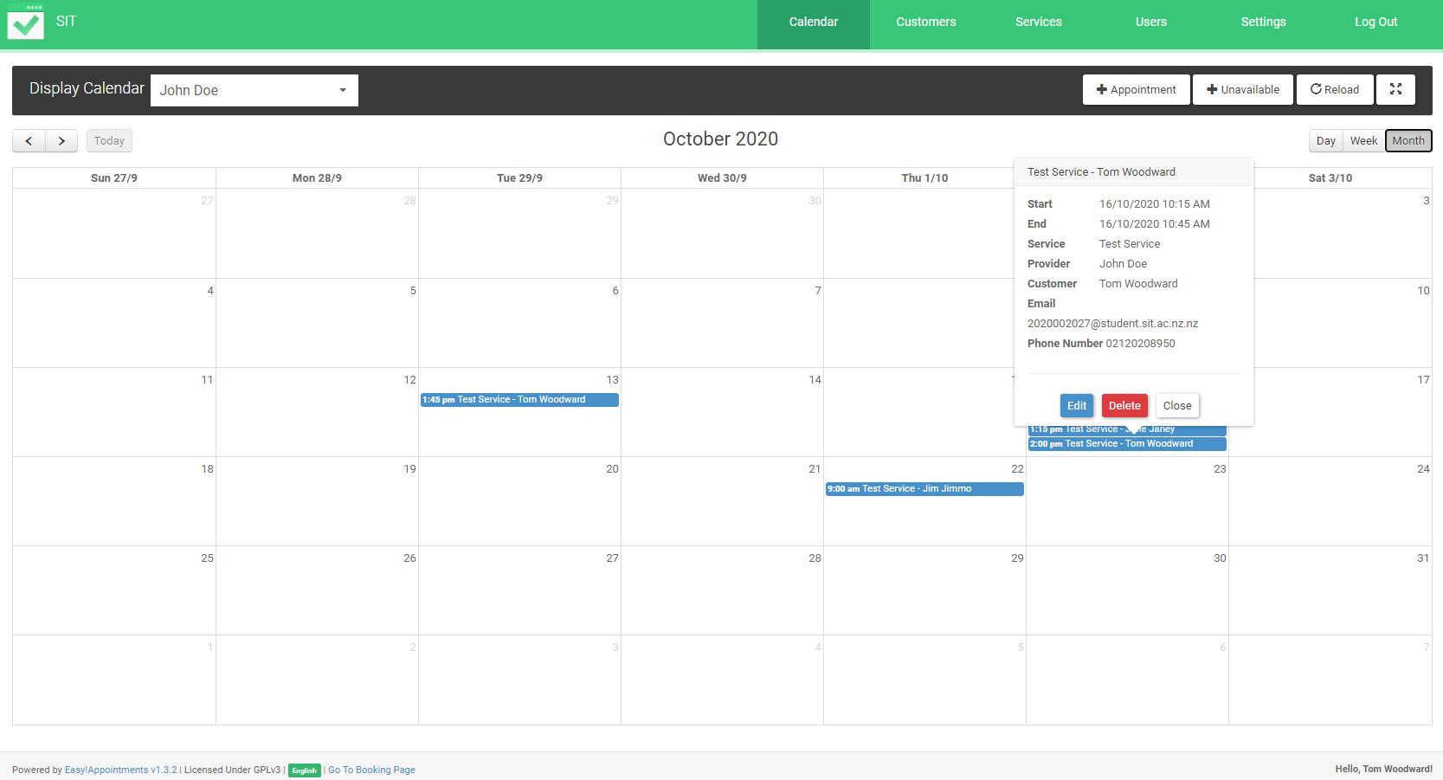
10. Edit appointment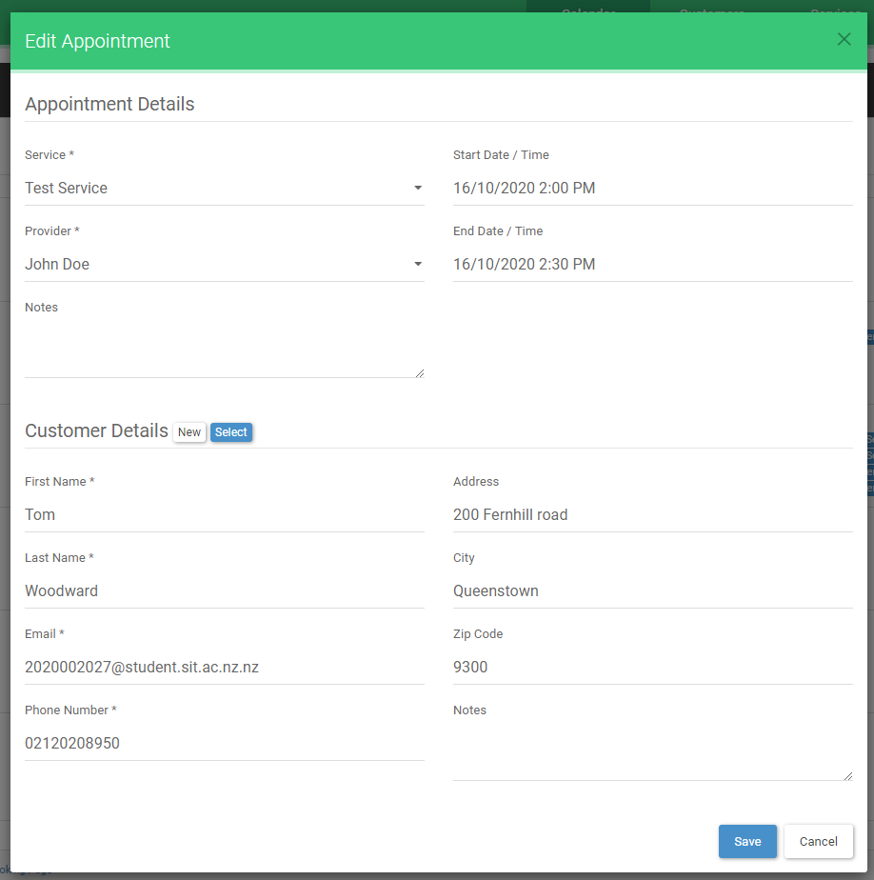

## Add customer

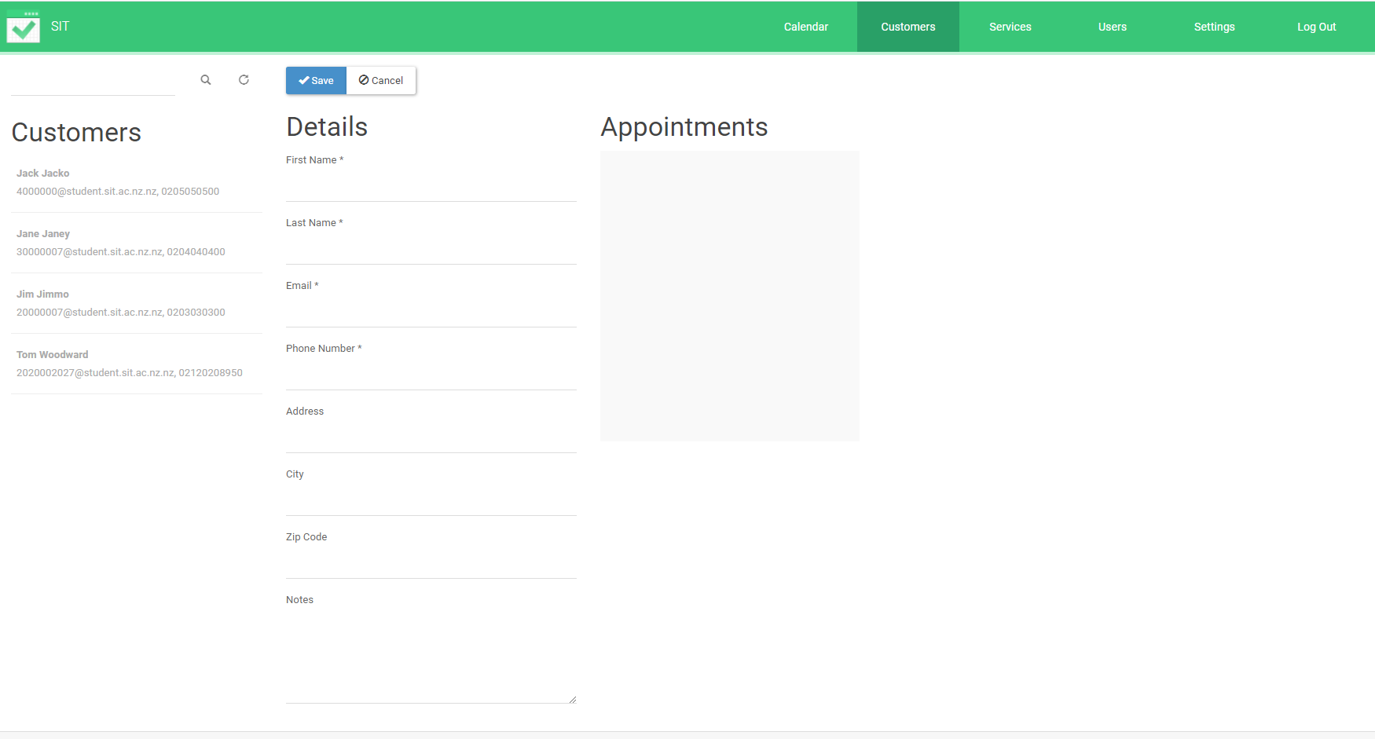

## Check customer details

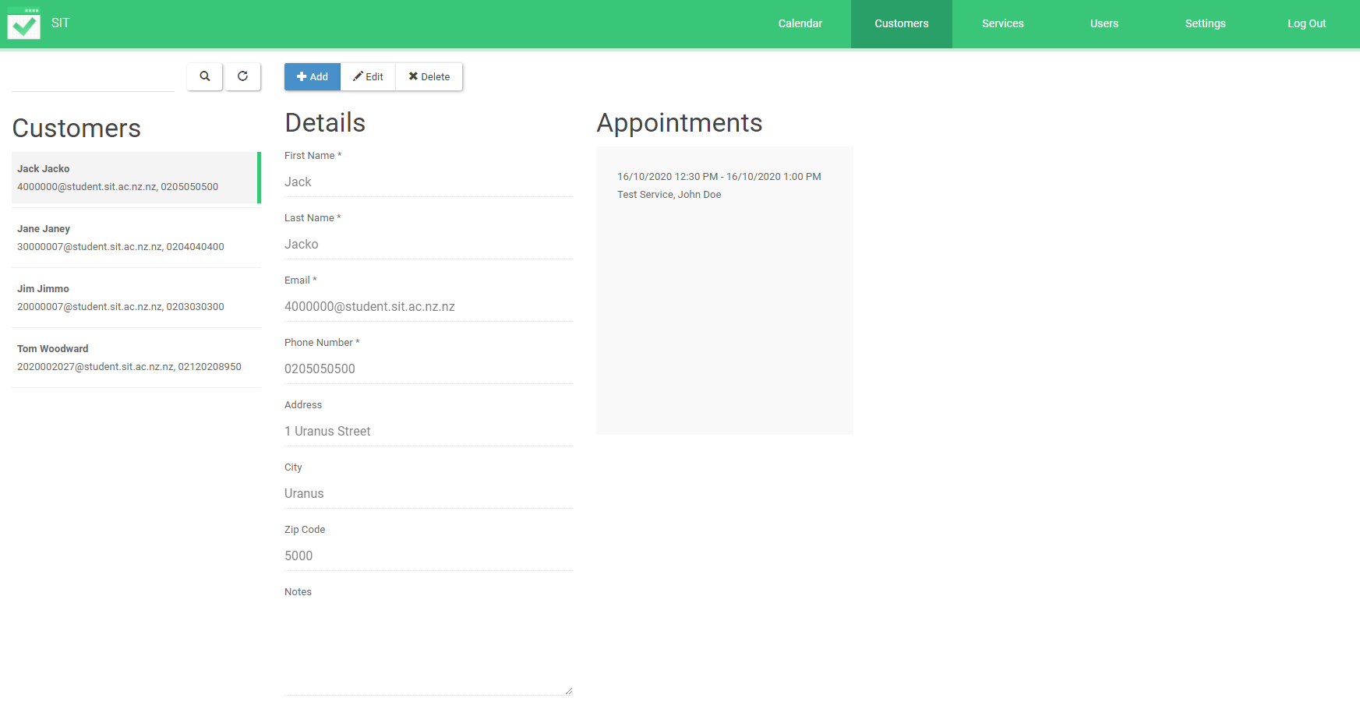

1. Add services 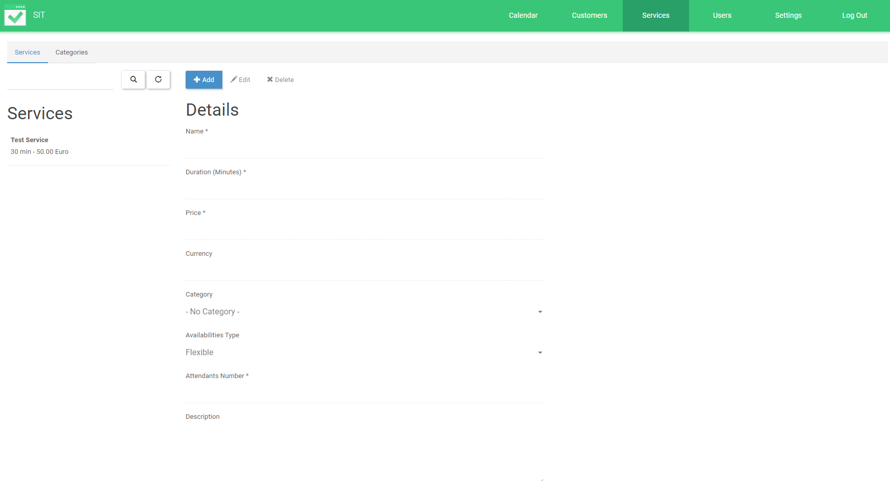

## Check Service

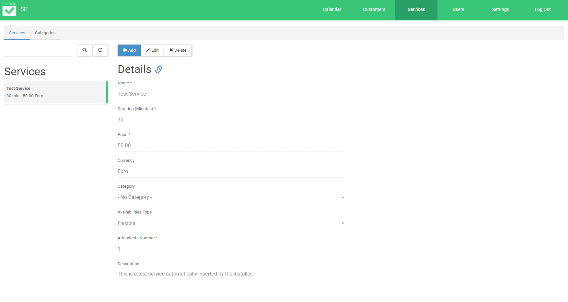

## Add providers

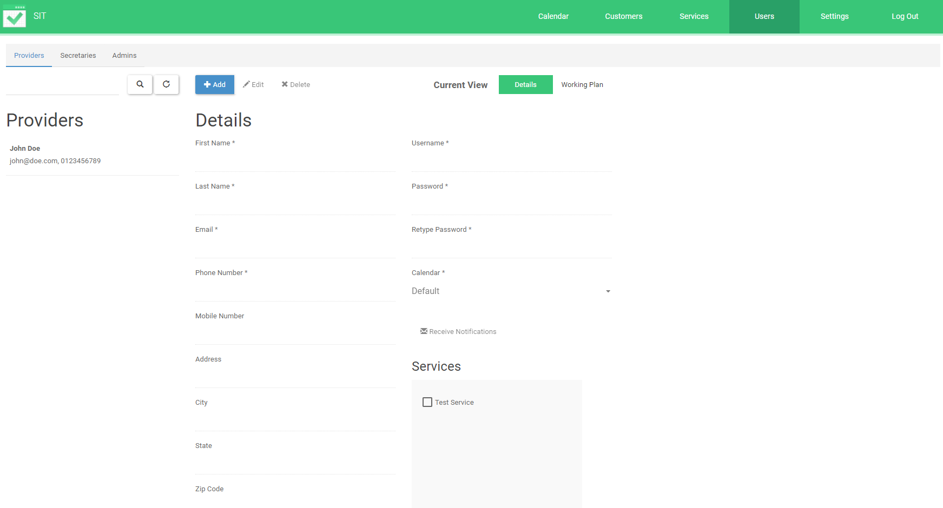

## Check providers details

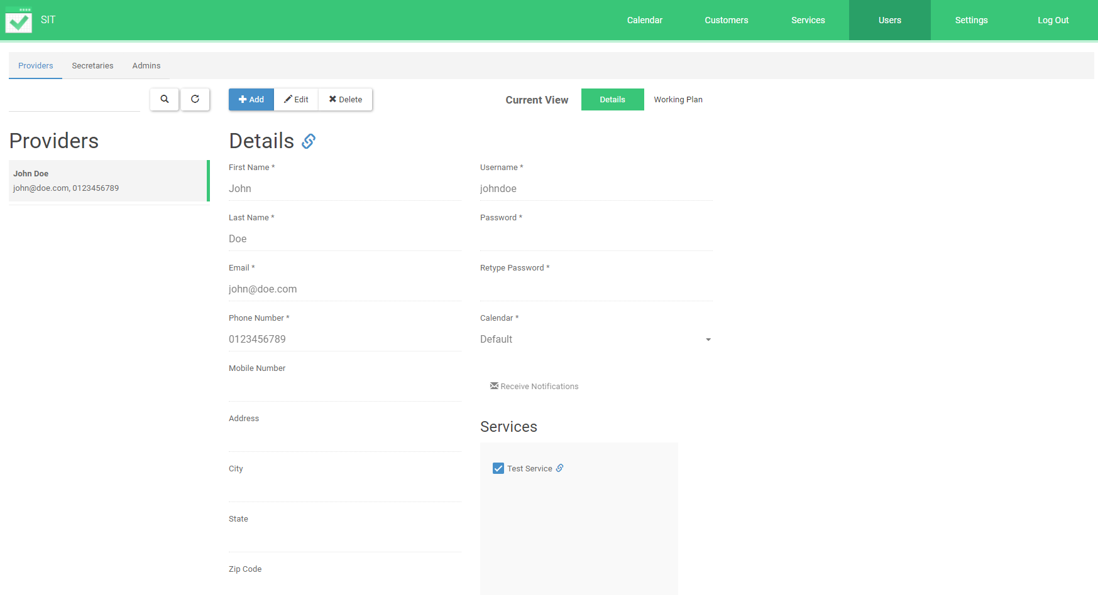

## Settings General

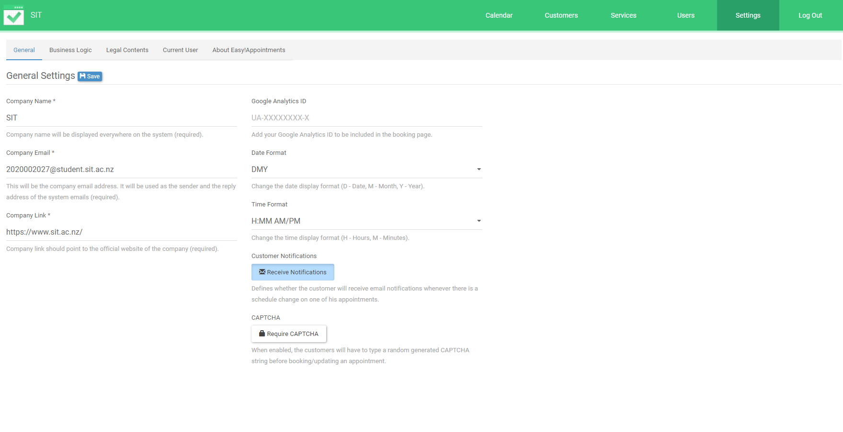

1. Settings business logic

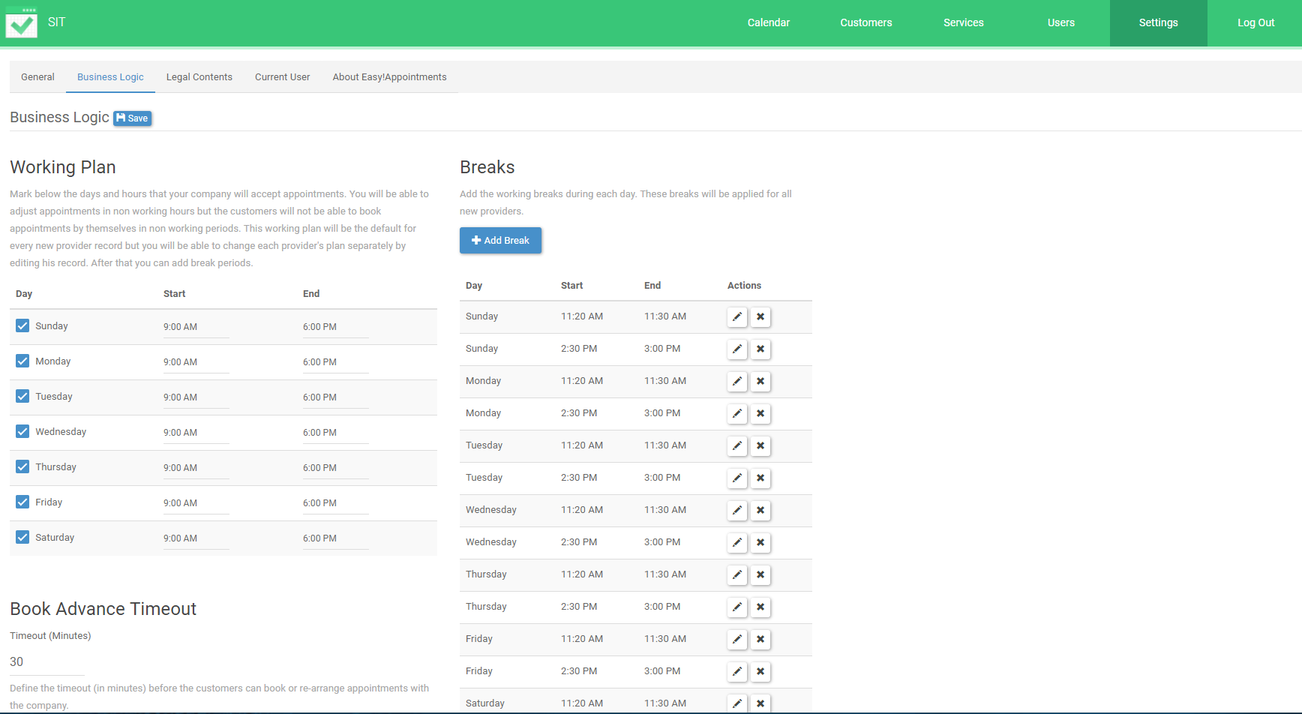

1. Settings legal contracts

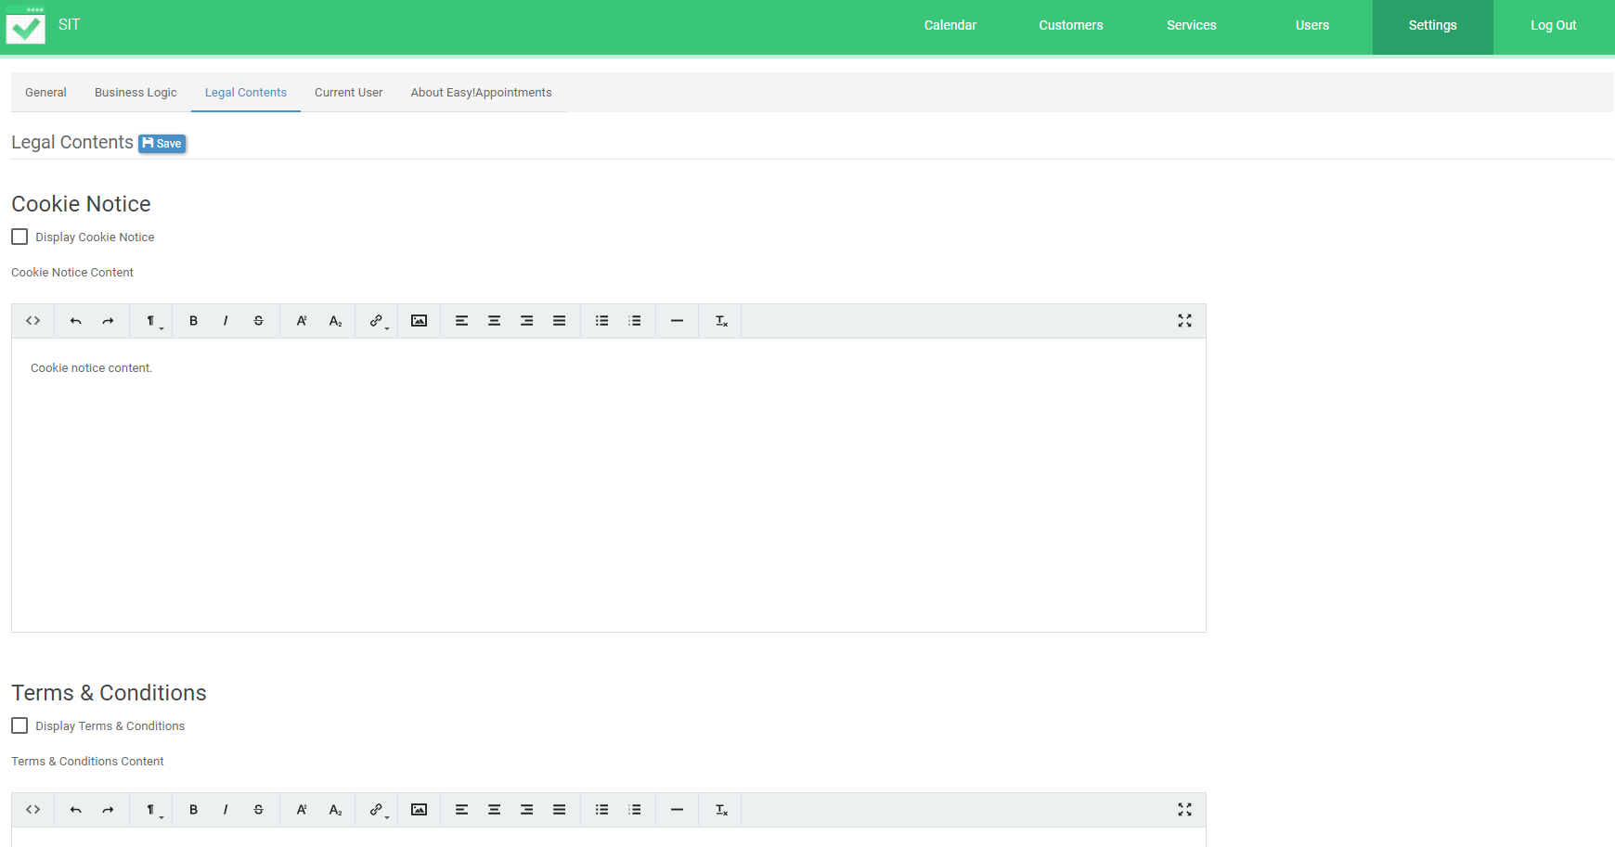

1. Settings Current User

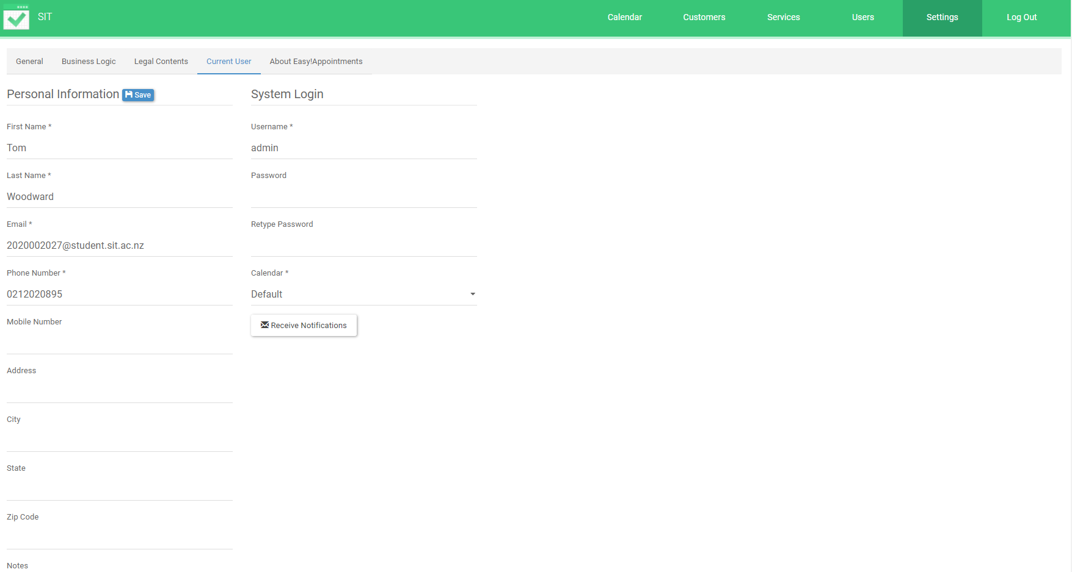

1. Settings About Easy Appointments

